“**SMART TRAVEL”**

A Report submitted under Project-Based Learning

In Partial Fulfillment of the Course Requirements for

“Web Technologies (22IT104001)”

Submitted By

|  |  |
| --- | --- |
| Ch. Yoshitha | 22102A050010 |
| M. Tejaswi | 22102A050035 |
| P. Vishnu Vardhan Reddy | 22102A050045 |
| R. Ram Kumar | 22102A050049 |
| R. Hari Priya | 22102A050050 |

Under the Guidance of

M.SURYA

Department of IT



**Department of Information Technology**

**School of Computing**

**MOHAN BABU UNIVERSITY**

Sree Sainath Nagar, Tirupati – 517 102

**2024-2025**

 **MOHAN BABU UNIVERSITY**

**Vision**

To be a globally respected institution with an innovative and entrepreneurial culture that offers transformative education to advance sustainability and societal good.

**Mission**

* Develop industry-focused professionals with a global perspective.
* Offer academic programs that provide transformative learning experience founded on the spirit of curiosity, innovation, and integrity.
* Create confluence of research, innovation, and ideation to bring about sustainable and socially relevant enterprises.
* Uphold high standards of professional ethics leading to harmonious relationship with environment and society.

**SCHOOL OF COMPUTING**

**Vision**

To lead the advancement of computer science research and education that has real-world impact and to push the frontiers of innovation in the field.

**Mission**

* Instead within our students fundamental computing knowledge, a broad set of skills, and an inquisitive attitude to create innovative solutions to serve industry and community.
* Provide an experience par excellence with our state-of-the-art research, innovation, and incubation ecosystem to realize our learners’ fullest potential.
* Impart continued education and research support to working professionals in the computing domain to enhance their expertise in the cutting-edge technologies.
* Inculcate among the computing engineers of tomorrow with a spirit to solve societal challenges.

**DEPARTMENT OF INFORMATION TECHNOLOGY**

**Vision**

To become a Centre of Excellence in Computer Science and its emerging areas by imparting high quality education through teaching, training and research.

**Mission**

* Imparting quality education in Information Technology and emerging areas of IT industry by disseminating knowledge through contemporary curriculum, competent faculty and effective teaching-learning methodologies.
* Nurture research, innovation and entrepreneurial skills among faculty and students to contribute to the needs of industry and society.
* Inculcate professional attitude, ethical and social responsibilities for prospective and promising engineering profession.
* Encourage students to engage in life-long learning by creating awareness of the contemporary developments in Information Technology and its emerging areas.

**B.Tech. Information Technology**

**PROGRAM EDUCATIONAL OBJECTIVES**

After few years of graduation, the graduates of B.Tech. CSE will be:

**PEO1**. Pursuing higher studies in core, specialized or allied areas of Computer Science, or Management.

**PEO2**. Employed in reputed Computer and I.T organizations or Government to have a globally competent professional career in Information Technology domain or be successful Entrepreneurs.

**PEO3.** Able to demonstrate effective communication, engage in teamwork, exhibit leadership skills and ethical attitude, and achieve professional advancement through continuing education.

**PROGRAM OUTCOMES**

On successful completion of the Program, the graduates of B.Tech. CSE Program will be able to:

1. **Engineering Knowledge**: Apply the knowledge of mathematics, science, engineering fundamentals, and an engineering specialization to the solution of complex engineering problems.
2. **Problem Analysis**: Identify, formulate, review research literature, and analyze complex engineering problems reaching substantiated conclusions using first principles of mathematics, natural sciences, and engineering sciences.
3. **Design/Development of Solutions**: Design solutions for complex engineering problems and design system components or processes that meet the specified needs with appropriate consideration for the public health and safety, and the cultural, societal, and environmental considerations.
4. **Conduct Investigations of Complex Problems**: Use research-based knowledge and research methods including design of experiments, analysis and interpretation of data, and synthesis of the information to provide valid conclusions.
5. **Modern Tool Usage**: Create, select, and apply appropriate techniques, resources, and modern engineering and IT tools including prediction and modeling to complex engineering activities with an understanding of the limitations.
6. **The Engineer and Society**: Apply reasoning informed by the contextual knowledge to assess societal, health, safety, legal and cultural issues and the consequent responsibilities relevant to the professional engineering practice.
7. **Environment and Sustainability**: Understand the impact of the professional engineering solutions in societal and environmental contexts, and demonstrate the knowledge of, and need for sustainable development.
8. **Ethics**: Apply ethical principles and commit to professional ethics and responsibilities and norms of the engineering practice.
9. **Individual and Team Work**: Function effectively as an individual, and as a member or leader in diverse teams, and in multidisciplinary settings.
10. **Communication**: Communicate effectively on complex engineering activities with the engineering community and with society at large, such as, being able to comprehend and write effective reports and design documentation, make effective presentations, and give and receive clear instructions.
11. **Project Management and Finance**: Demonstrate knowledge and understanding of the engineering and management principles and apply these to one’s own work, as a member and leader in a team, to manage projects and in multidisciplinary environments.
12. **Life-long Learning**: Recognize the need for, and have the preparation and ability to engage in independent and life-long learning in the broadest context of technological change.

**PROGRAM SPECIFIC OUTCOMES**

On successful completion of the Program, the graduates of B. Tech. (CSE) program will be able to:

**PSO1.** Apply knowledge of computer science engineering, Use modern tools, techniques and technologies for efficient design and development of computer-based systems for complex engineering problems.

**PSO2.** Design and deploy networked systems using standards and principles, evaluate security measures for complex networks, apply procedures and tools to solve networking issues.

**PSO3.** Develop intelligent systems by applying adaptive algorithms and methodologies for solving problems from inter-disciplinary domains.

**PSO4.** Apply suitable models, tools and techniques to perform data analytics for effective decision making.

|  |  |  |  |  |  |  |
| --- | --- | --- | --- | --- | --- | --- |
| **Course Code** | **Course Title** | **L** | **T** | **P** | **S** | **C** |
| **22IT104001** | **WEB TECHNOLOGIES** | 3 | - | 2 | 4 | 5 |

**COURSE OUTCOMES:** *After successful completion of this course, the students will be able to:*

1. Demonstrate knowledge on web page design elements, dynamic content and database connection.
2. Analyze user requirements to develop web applications.
3. Design client-server applications using web technologies.
4. Demonstrate problem solving skills to develop enterprise web applications.
5. Apply HTML, CSS, JavaScript, JQuery, Bootstrap and PHP technologies for device independent web application development.
6. Apply web technologies to develop interactive, dynamic and scalable web applications for societal needs.

**CO-PO-PSO Mapping Table:**

| **Course Outcomes** | **Program Outcomes** | | | | | | | | | | | | **Program Specific Outcomes** | | | |
| --- | --- | --- | --- | --- | --- | --- | --- | --- | --- | --- | --- | --- | --- | --- | --- | --- |
| **PO1** | **PO2** | **PO3** | **PO4** | **PO5** | **PO6** | **PO7** | **PO8** | **PO9** | **PO10** | **PO11** | **PO12** | **PSO1** | **PSO2** | **PSO3** | **PSO4** |
| **CO1** | 3 | 3 | 2 | - | - | - | - | - | - | - | - | - | 3 | 2 | 3 | - |
| **CO2** | 3 | 3 | 3 | 2 | 2 | - | - | - | - | - | - | - | 3 | 2 | 3 | - |
| **CO3** | 3 | 3 | 3 | 2 | 2 | - | - | - | - | - | - | - | 3 | 2 | 3 | - |
| **CO4** | 3 | 3 | 3 | 2 | 2 | - | - | - | - | - | - | - | 2 | 2 | 3 | - |
| **CO5** | 3 | 2 | 2 | 2 | 2 | 3 | - | - | - | - | - | - | 2 | 2 | 3 | - |
| **CO6** |  |  |  | 2 |  |  |  |  | 3 | 3 |  |  |  |  |  |  |
| **Course Correlation Mapping** | 3 | 3 | 3 | 2 | 2 |  |  |  | 3 | 3 |  |  | 3 | 2 | 3 |  |

*Correlation Levels: 3: High; 2: Medium; 1: Low*



**Department of Information Technology**

This is to certify that the Project Entitled

**“SMART TRAVEL”**

Submitted By

|  |  |
| --- | --- |
| Ch. Yoshitha | 22102A050010 |
| M. Tejaswi | 22102A050035 |
| P. Vishnu Vardhan Reddy | 22102A050045 |
| R. Ram Kumar | 22102A050049 |
| R. Hari Priya | 22102A050050 |

is the work submitted under Project-Based Learning in Partial Fulfillment of the Course Requirements for “Web Technologies (22IT104001)” during 2024-2025.

**Supervisor: Head:**

Dr. P. K. Gupta

M. Surya Professor & Head

Department of IT Department of IT

School of Computing School of Computing

Mohan Babu University Mohan Babu University

Tirupati. Tirupati.

**ACKNOWLEDGEMENTS**

First and foremost, I extend my sincere thanks to **Dr. M. Mohan Babu**, Chancellor, for his unwavering support and vision that fosters academic excellence within the institution.

My gratitude also goes to **Mr. Manchu Vishnu, Pro-Chancellor**, for creating an environment that promotes creativity and for his encouragement and commitment to student success.

I am deeply appreciative of **Prof. Nagaraj Ramrao**, **Vice Chancellor,** whose leadership has created an environment conducive to learning and innovation.

I would like to thank **Dr. K. Saradhi**, Registrar, for his support in creating an environment conducive to academic success.

My sincere thanks to **Dr. B.M. Satish**, Dean of the School of Engineering and Computing, for his valuable support and guidance in all academic matters.

I am also grateful to **Dr. P.K.Gupta** Head of the Department of Information Technology, for her valuable insights and support.

Finally, I would like to express my deepest appreciation to my project supervisor, **M. Surya** Department of Information Technology for continuous guidance, encouragement, and expertise throughout this project.

Thank you all for your support and encouragement.

**Table of Contents**

| **Chapter No.** | **Title** | | **Page No.** |
| --- | --- | --- | --- |
|  | **Abstract** | | 1 |
| **1** | **Introduction** | | **2** |
|  | 1.1 | Problem Statement | 2 |
|  | 1.2 | Importance of the Problem | 2 |
|  | 1.3 | Objectives | 2 |
|  | 1.4 | Scope of the Project | 3 |
| **2** | **System Design** | | 5 |
|  | 2.1 | Architecture Diagram | 5 |
|  | 2.2 | Module Descriptions | 6 |
|  | 2.3 | Database Design | 7 |
| **3** | **Implementation** | | 9 |
|  | 3.1 | Tools and Technologies Used | 9 |
|  | 3.2 | Front-End Development | 9 |
|  | 3.3 | Back-End Development | 10 |
|  | 3.4 | Integration | 12 |
| **4** | **Testing, Results and Discussion** | | 13 |
|  | 4.1 | Test Cases | 13 |
|  | 4.2 | Testing Methods | 15 |
|  | 4.3 | Output Screenshots | 16 |
|  | 4.4 | Analysis of Results | 23 |
| **5** | **Conclusion** | | 24 |
|  | 5.1 | Summary of Findings | 24 |
|  | 5.2 | Future Enhancements | 24 |
| **6** | **Appendix** | | 26 |
|  | 6.1 | Code Snippets | 26 |

**ABSTRACT**

This mini-project presents a tourism travel platform dedicated to promoting journeys to famous and historical destinations, with a particular focus on enhancing accessibility and convenience for travelers. The platform enables customers to explore and book trips to culturally significant sites, ensuring a smooth travel experience with comprehensive transportation services.

The main goal is to simplify the travel planning process, providing a user-friendly interface where customers can select from various historical destinations, view itineraries, and choose preferred modes of transport.

The system incorporates features such as location descriptions, customer registration, travel package options, and a secure booking system.

By offering transport facilities, the platform aims to improve travel convenience and accessibility, encouraging tourists to discover and appreciate historical and cultural landmarks.

Designed to be both informative and functional, this project targets tourists interested in exploring the heritage and history of different regions, aiming to deliver a stress-free, enriching travel experience.

**1. Introduction**

**1.1 Problem Statement**

Travelers interested in exploring historical and culturally significant sites often encounter challenges in organizing seamless and convenient trips. These challenges include difficulty accessing reliable information about historical destinations, coordinating transportation, finding trusted travel arrangements, and managing multiple bookings for a single trip. As a result, tourists may experience stress and inefficiency in planning, leading to missed opportunities to fully enjoy the historical places they wish to visit. This project seeks to address these issues by developing an integrated tourism platform that centralizes travel planning, with features designed to simplify the experience for users. The platform will provide detailed information about famous and lesser-known historical sites, offer convenient transportation options to reach these destinations, and facilitate easy booking of travel packages.

**1.2 Importance of the Problem**

The importance of addressing the challenges faced by travelers interested in historical tourism lies in both preserving cultural heritage and enhancing user experience. Historical tourism plays a significant role in promoting awareness of cultural and historical values, supporting local economies, and contributing to heritage conservation. However, the barriers to easy access, reliable information, and secure arrangements can deter potential travelers, leading to missed opportunities for both individuals and communities.

By developing a platform that integrates these elements, travelers can more easily access important cultural and historical sites, potentially increasing tourism in areas that benefit economically from visitor engagement. Additionally, a seamless travel experience can reduce planning stress, enhance enjoyment, and encourage repeat visits, which helps foster a deeper connection to cultural heritage. Addressing these issues is crucial not only for improving individual travel experiences but also for supporting sustainable tourism, which in turn preserves historical landmarks and cultural sites for future generations.

**1.3 Objectives**

The objectives of this tourism travel platform project are as follows:

**1.Provide Reliable Information:** Create a comprehensive database of famous and lesser-known historical destinations, including site descriptions, historical significance, local attractions, and suggested itineraries, to help users make informed travel choices.

**2.Facilitate Seamless Trip Planning:** Develop a user-friendly interface that enables travelers to easily browse destinations, select travel packages, and access essential information without hassle.

**3.Offer Transportation Solutions:** Integrate various transport options to facilitate convenient travel to historical sites, especially those in remote or less accessible areas, ensuring a smooth travel experience.

**4.Enable Secure and Simple Booking:** Implement a streamlined booking and payment system that allows users to make secure reservations and receive automated confirmations, reducing the complexity of trip planning.

**5.Enhance User Experience:** Incorporate features such as user feedback, ratings, and reviews to enable travelers to make better-informed decisions based on the experiences of previous customers.

**6.Promote Cultural Awareness:** Encourage interest in historical and cultural sites by highlighting their significance and offering personalized travel experiences that promote appreciation and awareness of cultural heritage.

**7.Support Local Tourism:** Boost tourism in historical regions, thereby contributing to local economies and helping sustain the preservation of cultural and historical landmarks.

**8.Encourage Repeat Visits:** Provide an enjoyable and stress-free travel planning experience to foster customer loyalty, encouraging users to explore new destinations and return for future trips.

By meeting these objectives, the platform aims to create a holistic travel experience that makes historical tourism accessible, convenient, and appealing to a wider audience.

|  |  |
| --- | --- |
| **1.4** | **Scope of the Project** |
|  |  |

The scope of this tourism travel platform project is to design and deploy an online system that simplifies travel planning for historical and cultural destinations. Key features include:

**1. Destination Database:** A catalog with detailed descriptions, images, and historical backgrounds of famous and lesser-known sites.

**2. User Interface (UI):** An intuitive interface for easy browsing, searching, and booking.

**3. Itinerary and Transportation Options:** Customizable travel itineraries and transport options, making remote destinations more accessible.

**4. Booking and Payment System:** A secure, multi-payment booking system to simplify reservations.

**5. User Profiles:** Accounts for personalized recommendations and easy access to booking history.

**6. Feedback and Ratings:** A review system for users to share experiences and guide future travelers.

**7. Customer Support:** Assistance through FAQs, chat, or email for booking-related queries.

**8. Promotions:** Seasonal offers and loyalty rewards to attract and retain users.

The project is designed for initial deployment in a single country with scalability for future expansion, offering a comprehensive solution for tourists to explore cultural and historical landmarks easily.

**2.System Design**

**2.1 Architecture Diagram**

**Data Flow Diagram(DFD)**

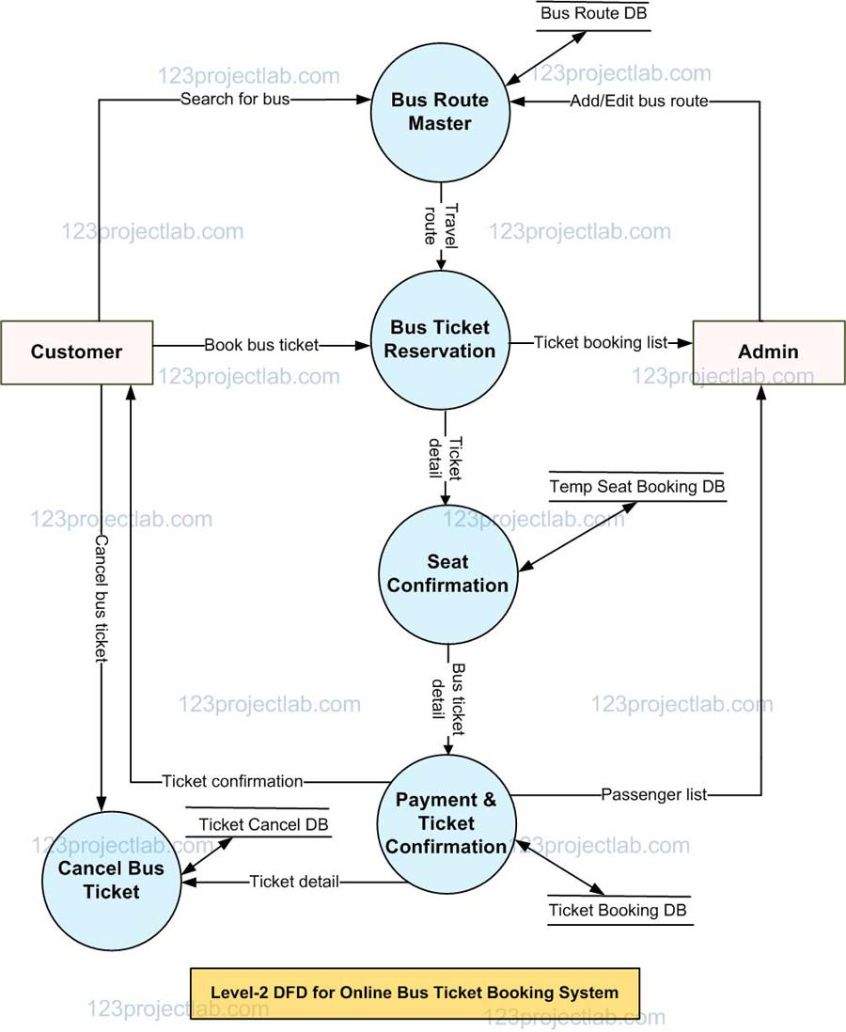

**2.2 Module Description**

**Login Details:** The login process allows users to access the system with secure authentication. Users create an account with credentials (typically a username or email and a password) or log in using an existing social media or email account. This ensures that personal information and booking history are stored securely and only accessible to the user. After logging in, users can view their profile, booking history, and any saved preferences, streamlining the booking process.

**Selecting the Place:** In this step, users can choose their desired destination, venue, or event. The system provides a searchable list or map view, along with relevant filters (such as date, location, and category) to help users find the perfect place. Once the user selects a location, additional details such as availability, timings, and descriptions are displayed, giving them a comprehensive view before proceeding.

**Seat Selection:** After choosing a location, users can select their preferred seats from a visual layout. The seat selection interface shows the available seats in real time, often color-coded (for example, green for available, red for booked) to indicate availability. Users can choose single or multiple seats based on their preference, and the system automatically updates the total cost based on the chosen seats.

**Payment Process:** The payment process finalizes the booking. Users are redirected to a secure payment gateway where they can choose from various payment methods, such as credit/debit cards, digital wallets, or bank transfers. The system ensures a secure transaction, protecting user data with encryption. Once the payment is confirmed, a booking confirmation is generated, and a digital ticket is issued, which the user can download or receive via email/SMS.

**2.3Data Base Design**

**1.User Management:**

This section is responsible for storing and managing user information, ensuring secure login and personal data handling. It includes account details, contact information, and preferences.

**Purpose:** Allow users to create accounts, log in, and manage personal data.

**Key Features:** User authentication, profile management, and secure login.

**2. Places Management:**

This section stores details about various places, such as cities, venues, or event locations, where ticketed events will occur. It allows users to explore different locations for events.

**Purpose:** Provide users with a list of available locations for events.

**Key Features:** Location name, description, address, and geographical information.

**3. Event Management:**

Manages information about the events or activities that are hosted at the places. It includes details like event name, description, timing, and the associated place.

**Purpose**: Let users browse and select events for ticket booking.

**Key Features:** Event name, date, time, place association, and capacity.

**4. Seat Management:**

This section handles the availability of seats for each event. It stores seat details like seat numbers, sections, availability, and pricing.

**Purpose:** Enable users to select available seats based on their preferences.

**Key Features:** Seat number, section, availability, and price.

**5. Booking Management:**

This section tracks the bookings made by users. It stores data about the user, the event, the selected seats, booking status, and pricing.

**Purpose:** Allow users to book tickets and manage their bookings.

**Key Features:** Booking details, status, seat selection, total price.

**6. Payment Processing:**

Manages payment information and tracks the status of payments made for bookings. It ensures that payments are securely processed and recorded.

**Purpose:** Handle transactions for ticket purchases.

**Key Features:** Payment method, amount, status, and transaction details.

**7. Notifications:**

Stores and manages the notifications sent to users regarding their bookings, payments, and event reminders.

**Purpose:** Keep users informed about their bookings, events, and any changes.

**Key Features**: Confirmation messages, reminders, and notifications.

**8. Search:**

Allows users to search for events and places based on criteria such as location, date, type of event, or availability.

**Purpose:** Improve user experience by offering an efficient search and filter mechanism.

**Key Features:** Search by location, event type, and filter by availability or price.

This structured approach to database design ensures that all key aspects of a ticket booking system are covered, from user management to event bookings and payments. It allows for efficient data handling, ensuring a smooth and secure user experience.

**3.Implementation**

**3.1 Tools and Technologies Used**

The main objective of the Smart Travel is to help the people to book their travelling ticket through online with in easier way with security.

**Software Requirements**

* Front End Tools
* HTML
* CSS
* JAVASCRIPT
* PHP
* Back End Tools
* MYSQL

**3.2 Front-End Development**

**HTML (Hypertext Markup Language):**

HTML is the foundational language for creating web pages, providing the basic structure and elements that make up a website. It uses a system of tags to define content, such as headings, paragraphs, images, and links, which browsers interpret to display the page to users. HTML is essential for organizing content and ensuring it appears correctly across different devices.

**CSS (Cascading Style Sheets):**

CSS is a styling language used to design and format the appearance of web pages. It controls visual aspects like layout, colors, fonts, and spacing, enabling developers to make a web page visually appealing and consistent across various devices. By separating content (HTML) from design (CSS), CSS allows for flexible and efficient web page styling.

**JAVASCRIPT:**

JavaScript is a versatile programming language that brings interactivity and dynamic content to websites. It allows developers to add features such as animations, form validation, dropdown menus, and real-time data updates. JavaScript runs on the client side, meaning it executes directly in the user’s browser, making websites more responsive and engaging for users.

**PHP (Hypertext Preprocessor):**

PHP is a server-side scripting language designed for web development, allowing developers to build dynamic and interactive web pages. It works seamlessly with HTML and databases like MySQL, enabling developers to retrieve and display data, handle forms, and manage user sessions. PHP is widely used for building content-rich and data-driven websites.

**3.3 Back-End Development**

**MySQL:**

MySQL is an open-source relational database management system (RDBMS) that stores and manages data in a structured format using tables. It allows developers to perform operations like querying, updating, and managing large datasets efficiently. MySQL is commonly used with web applications to handle data such as user information, product details, and content management.

**3.4 Integration**

The ticket booking system integrates multiple processes to help users find a place and book tickets seamlessly. First, users search for available places such as cities or venues, with the system retrieving relevant results from the Places Table.

Once a place is selected, the system displays events associated with that location by querying the Events Table. Each event includes important details such as date, time, description, and capacity. After choosing an event, the user proceeds to select seats, with the system checking seat availability from the Seats Table.

The seating options are shown in real-time, with available seats marked accordingly, and the user selects their preferred seat. Once the seat is chosen, the system updates the Seats Table, marking the seat as unavailable to prevent double booking.

The system then calculates the total cost of the ticket and presents it to the user, including additional charges if applicable. Upon confirming the booking, a temporary record is created in the Bookings Table, holding the seat for the user until payment is processed. The user then proceeds to the payment process, where payment details are entered into a secure gateway. After successful payment, the system updates the Payments Table, confirming the transaction details and marking the payment as complete. The status of the booking in the Bookings Table is also updated to "confirmed".

**PHP Integration:**

❖ PHP scripts serve as the intermediary between the frontend and MySQL databases,

executing SQL queries to interact with the data.

❖ PHP scripts can retrieve data from MySQL databases to dynamically generate HTML

content, such as displaying exam questions or user results.

❖ Additionally, PHP scripts handle form submissions from HTML pages, processing user

input and storing data into MySQL databases.

**JavaScript Integration:**

❖ JavaScript enhances the user experience by providing interactive features and dynamic

content manipulation.

❖ JavaScript can make asynchronous HTTP requests (AJAX) to PHP scripts, which then

interact with MySQL databases to fetch data without reloading the entire webpage.

❖ This allows for real-time updates, dynamic content loading, and seamless user interactions, enhancing the responsiveness and usability of the system.

**HTML Forms and Data Submission:**

❖ HTML forms are used to collect user input, such as exam answers or login credentials.

❖ When a user submits a form, the data is sent to PHP scripts for processing.

❖ PHP scripts execute SQL queries to insert, update, or delete data in MySQL databases

based on the form submission.

**Server-side Data Processing:**

❖ MySQL databases store and manage the system's data, including exam questions, user

credentials, and exam results.

❖ PHP scripts execute SQL queries to retrieve relevant data from MySQL databases based

on user interactions and system requirements.

❖ Data retrieved from MySQL databases is processed, formatted, and sent back to the

frontend for display or further interaction.

**4.Testing, Results and Discussion**

**4.1 Test cases**

Unit testing is a level of software testing where individual units/ components of software are tested. The purpose is to validate that each unit of the software performs as designed. A unit is the smallest testable part of any software. It usually has one or a few inputs and usually a single output. In procedural programming, a unit may be an individual program, function, procedure, etc. in object-oriented programming, the smallest unit is a method, which may belong to a base/ super class, abstract class or derived/ child class. (Some treat a module of an application as a unit. It is concerned with functional correctness of the standalone modules. The main aim is to isolate each unit of the system to identify, analyze and fix the defects. A unit test is a way of testing a unit – the smallest piece of code that can be logically isolated in a system. In most programming languages, that is a function, a subroutine, a method or property. The isolated part of the definition is important.

**4.2Testing Methods:**

❖ **Black Box Testing -** Using which the user interface, input and output are tested.

❖ **White Box Testing** - used to test each one of those functions behaviors is tested.

❖ **Gray Box Testing** - Used to execute tests, risks and assessment methods.

**Integration Testing:**

Integration Testing is a level of software testing where individual units are combined and

tested as a group. The purpose of this level of testing is to expose faults in the interaction

between integrated units. Test drivers and test stubs are used to assist in Integration Testing. It is defined as a type of testing where software modules are integrated logically and tested as a group. A typical software project consists of multiple software modules, coded by different programmers. The purpose of this level of testing is to expose defects in the interaction between these software modules when they are Integrated Integration Testing focuses on checking data communication amongst these modules.

**Approaches, Strategies, Methodologies of Integration Testing:**

Software Engineering defines variety of strategies to execute Integration testing, viz.

❖ Big Bang Approach

❖ Incremental Approach**:** which is further divided into the following

▪ Top-Down Approach

▪ Bottom-Up Approach

▪ Sandwich Approach - Combination of Top Down and Bottom Up

**System Testing:**

**System Testing** is a level of testing that validates the complete and fully integrated software product. The purpose of a system test is to evaluate the end-to-end system specifications.

Usually, the software is only one element of a larger computer-based system. Ultimately, the software is interfaced with other software/hardware systems. System Testing is actually a series of different tests whose sole purpose is to exercise the full computer system.

**System Testing** is carried out on the whole system in the context of either system requirement specifications or functional requirement specifications or in the context of both.

System testing tests the design and behavior of the system and also the expectations of the customer. It is performed to test the system beyond the bounds mentioned in the software requirements specification (SRS). In system testing, integration testing passed components are taken as input.

The goal of integration testing is to detect any irregularity between the units that are integrated together. System testing detects defects within both the integrated units and the whole system.

The result of system testing is the observed behavior of a component or a system when it is tested. System Testing is basically performed by a testing team that is independent of the development team that helps to test the quality of the system impartial. It has both functional and nonfunctional testing.

**Types of System Testing:**

**Performance Testing:** Performance Testing is a type of software testing that is carried out to test the speed, scalability, stability and reliability of the software product or application.

**Load Testing:** Load Testing is a type of software Testing which is carried out to determine the behavior of a system or software product under extreme load.

**Stress Testing:** Stress Testing is a type of software testing performed to check the robustness of the system under the varying loads.

**Scalability Testing:** Scalability Testing is a type of software testing which is carried out to check the performance of a software application or system in terms of its capability to scale up or scale down the number of user request load.

.

**4.3 Output Screens:**

Fig1.1: Home Page

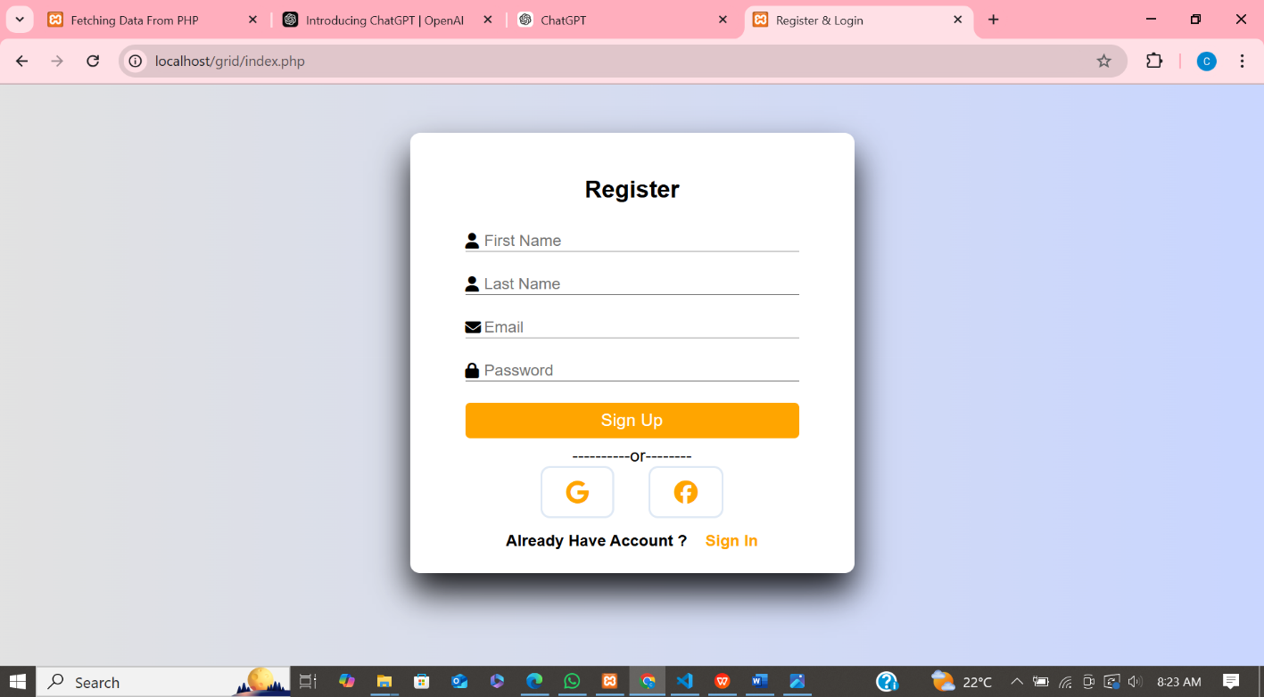

Fig1.2: Sign-up Page

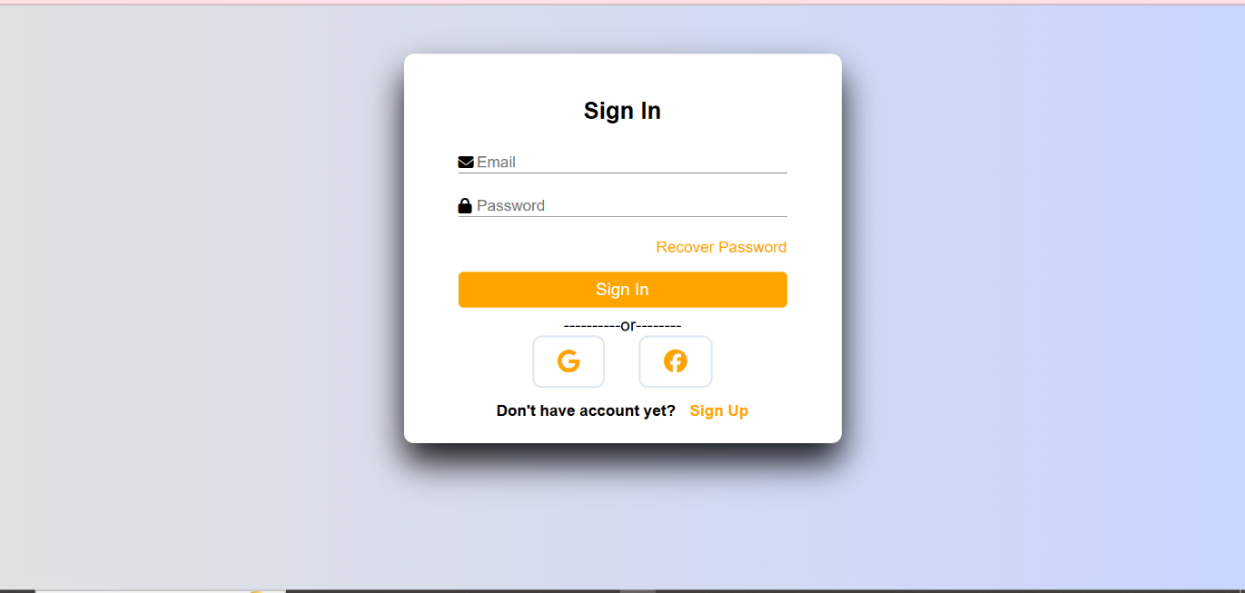

Fig1.3: Sign-in Page

Fig1.4: Selecting State Page

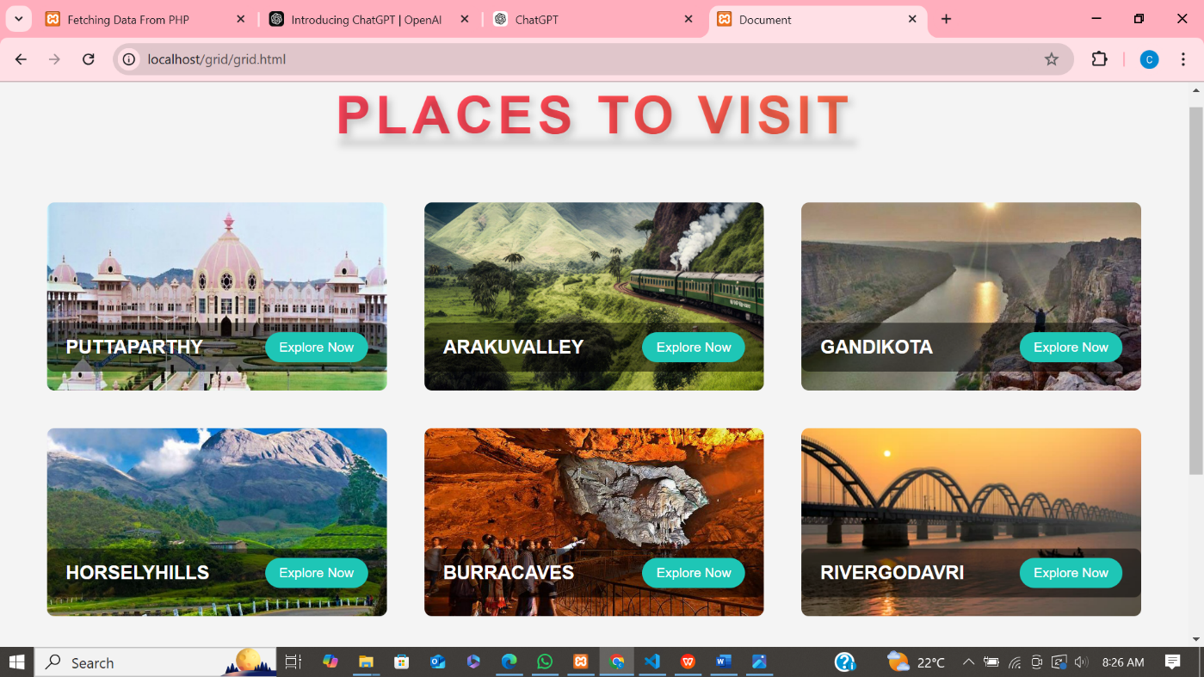

Fig1.5: Places to Visit

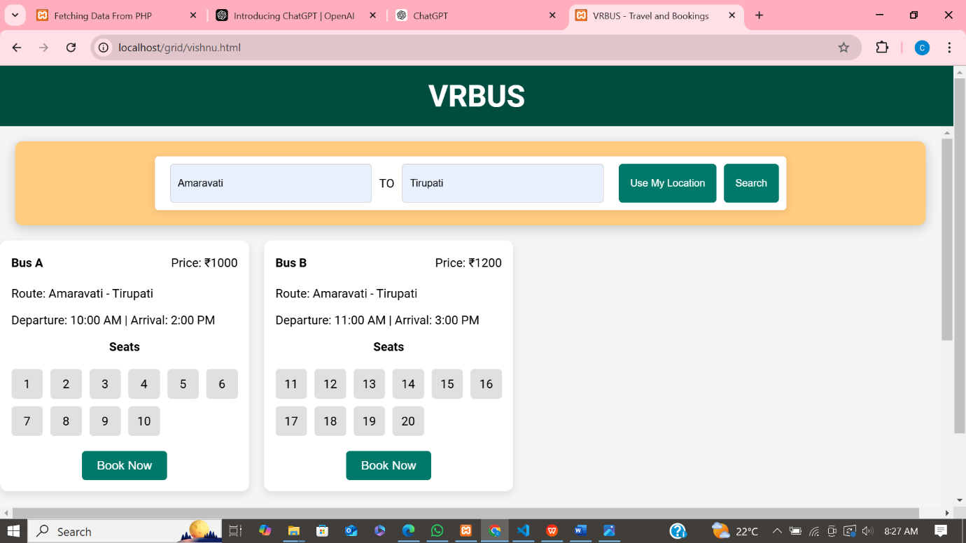

Fig1.6: Search Buses

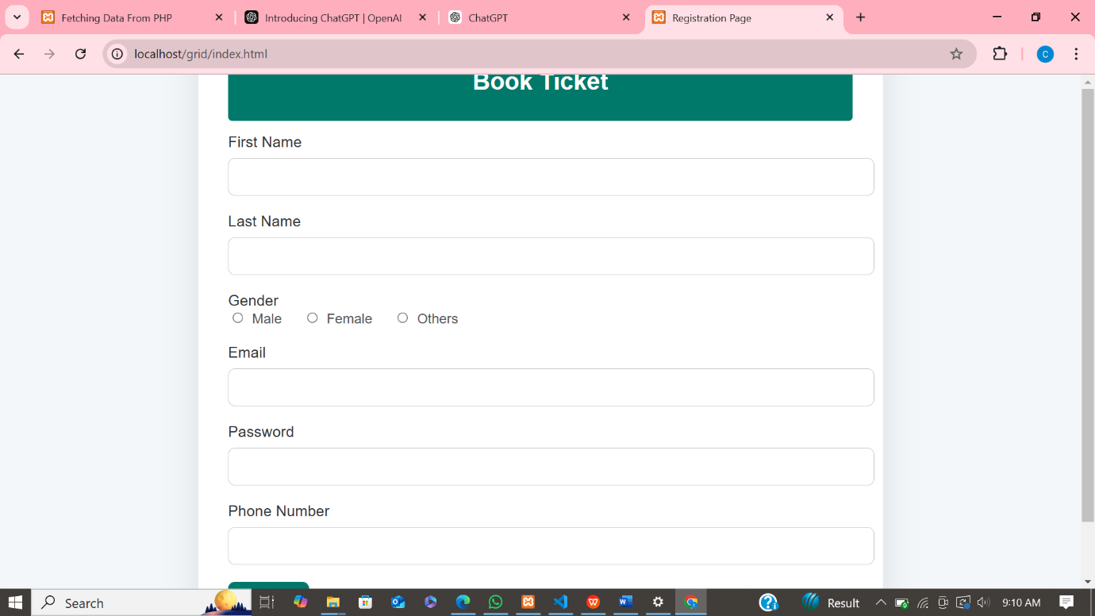Fig1.7: Book-Ticket Page

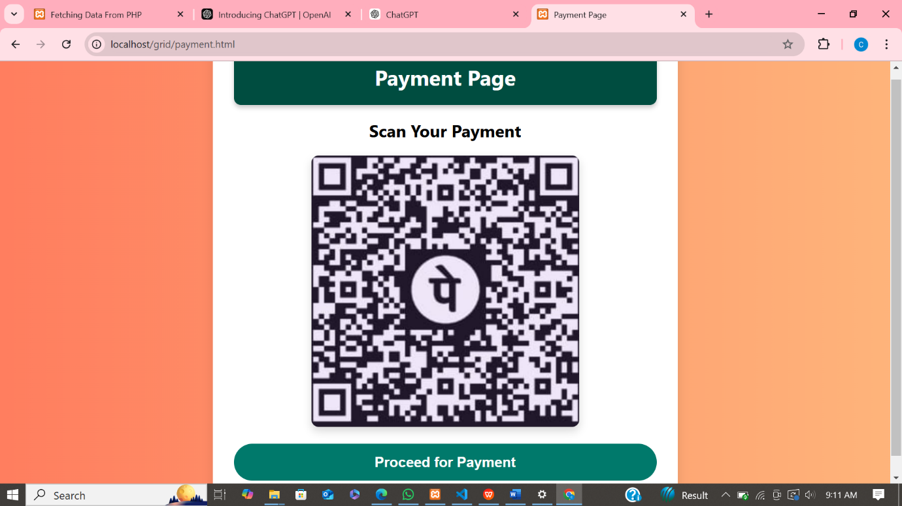

Fig1.8: Payment Page

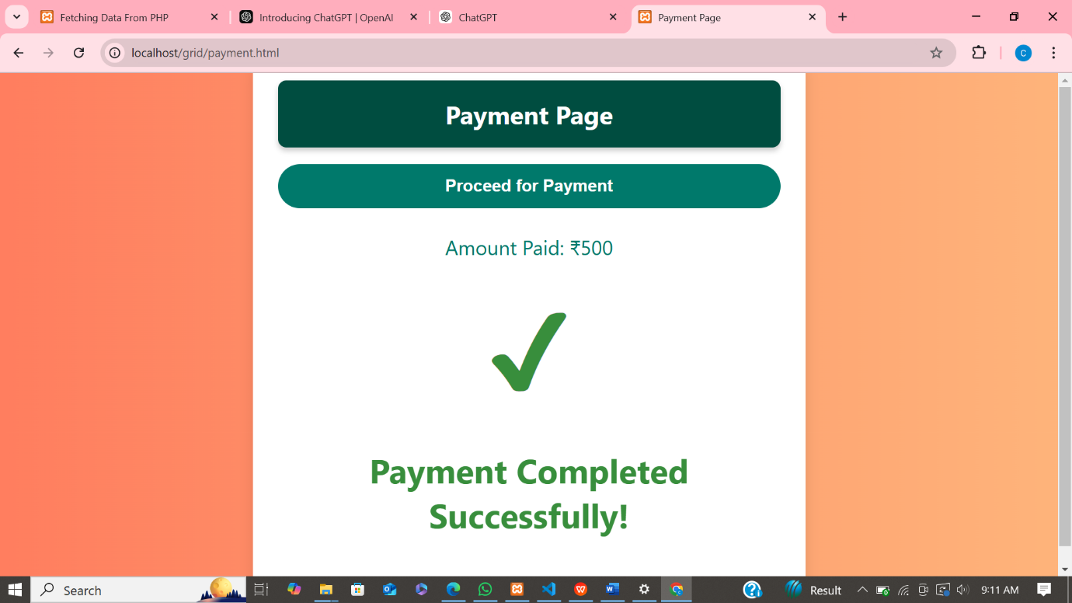Fig1.9: Payment Completion Page

Fig1.10: Fetch Data Page

**DATA BASES:**

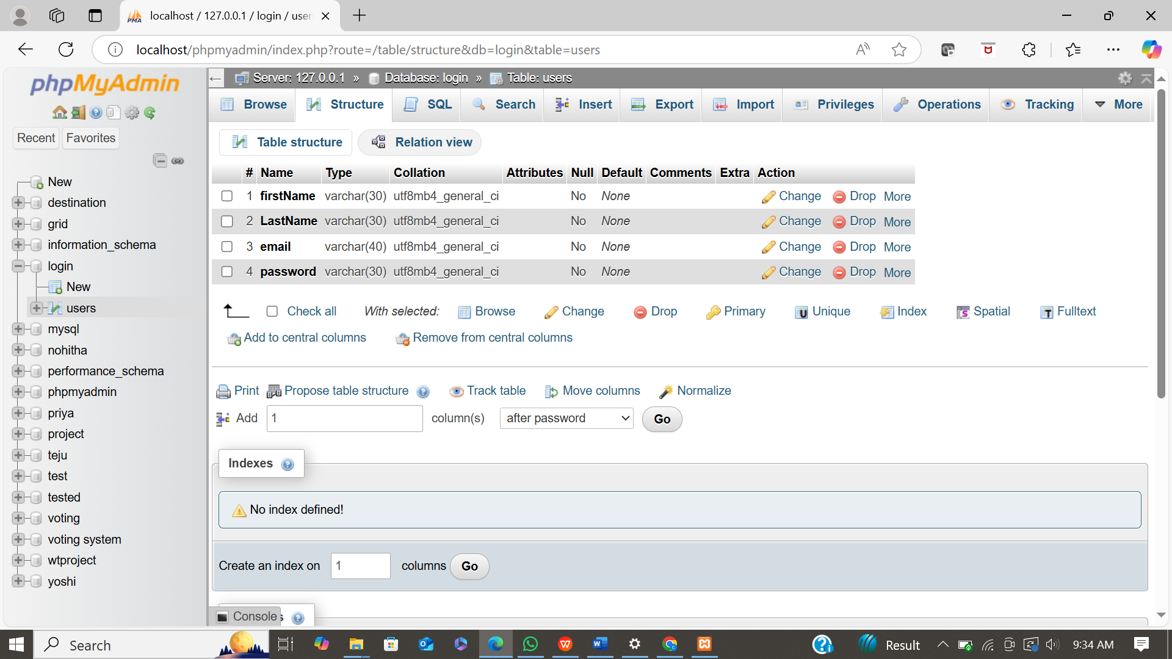

Fig2.1: Smart travel Login Data

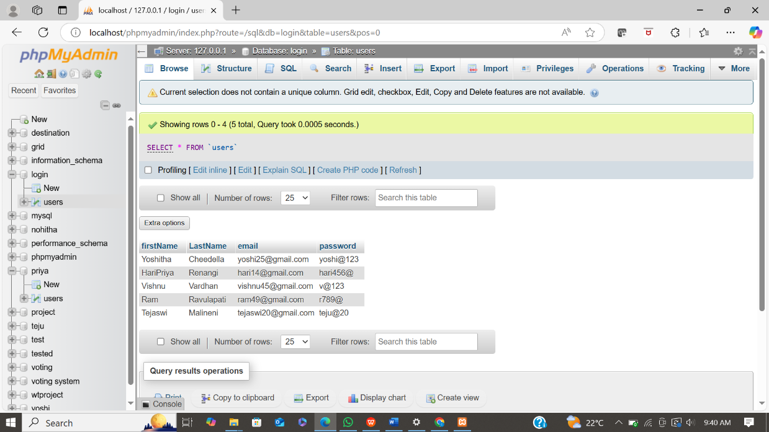

Fig2.2: Login Details

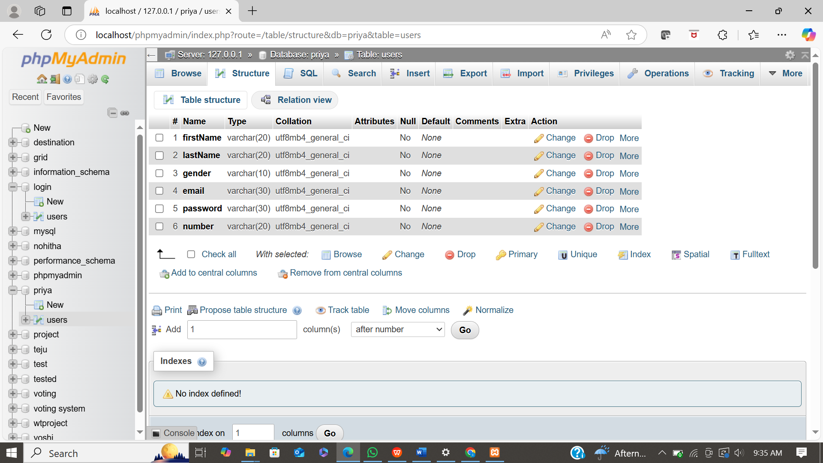

Fig2.3: Smart Travel Booking Data

Fig2.4: Booking Details

**4.4 Analysis of Results:**

An online bus booking system streamlines the process of reserving bus tickets by enabling users to search routes, select seats, make payments, and receive confirmations—all online. Key functionalities include secure user registration, detailed search and filter options, seat selection, payment integration, and automated ticket generation.

Additionally, the system sends notifications for confirmations, cancellations, and schedule changes, improving the user experience by keeping passengers informed. On the technical side, the system should have a scalable client-server architecture, with a robust backend for business logic and a responsive front end for an intuitive user interface.

Data security is paramount, especially for handling sensitive information like payment details, which necessitates encryption and adherence to security standards. A well-structured relational database is essential to manage and link entities such as users, buses, routes, and payments efficiently.

While the system offers convenience, reduced administrative costs, and real-time information for users and operators alike, challenges include managing high traffic, ensuring data security, and integrating with potential legacy systems used by bus operators.

Future enhancements might include live GPS tracking for buses, AI-based route recommendations, multi-language support, and customizable notifications. Overall, a well-designed online bus booking system brings significant value, making travel planning easier and more efficient for passengers and operators.

**5. Conclusion**

**5.1 Summary of Findings:**

The analysis of an online bus booking system highlights its key features and benefits for both users and operators. Essential functions include user registration, route search, seat selection, payment processing, and automated ticket issuance, with notifications for confirmations and schedule updates. Technologically, a scalable client-server model is required, with a secure backend to handle sensitive user and payment data, supported by a relational database that organizes users, routes, buses, and bookings.

The system's advantages include enhanced convenience, time and cost savings, and real-time availability. However, challenges such as high traffic management, data security, and integration with legacy systems must be addressed to ensure reliability and user satisfaction. Future improvements could include live bus tracking, AI-powered recommendations, multi-language support, and personalized notifications, making the system more user-centric and adaptable. Overall, the online bus booking system provides a streamlined, efficient solution for modern bus travel booking.

**5.2 Future Enhancements:**

Future enhancements to an online bus booking system could significantly improve the user experience and operational efficiency by integrating advanced features. Real-time GPS tracking would allow passengers to track bus locations and arrival times, enhancing convenience and reliability.

AI-powered recommendations and dynamic pricing could offer personalized suggestions and adjust ticket costs based on demand, optimizing revenue. Multi-language and multi-currency support would make the platform accessible to a wider audience, while customizable notifications enable users to choose how they receive updates. Additional payment options, loyalty programs, and user reviews would increase convenience and engagement, encouraging repeat bookings.

The user enters payment details through a secure gateway. Upon successful payment, the Payments Table is updated, marking the transaction as complete, and the booking status in the Bookings Table is changed to "confirmed."

**REFERENCES**

During the development of our system, we have taken the reference from Books and journals.

These books acted as our tutors during the system development..

* System Analysis And Design

- Kenneth E. Kendall, Julie E. Kendall

* An Analysis and Design of Information Systems

- Grayce M. Booth

* Software Engineering

- Roger S. Pressman

* Database Management System

- James A. Larson

* PHP: A Beginner’s Guide

- RiwantoMegosinarso

These are the following links which assist me at each and every step in completing this project,

* [Software Testing Tutorial](https://www.tutorialspoint.com/software_testing/index.htm)
* <https://www.geeksforgeeks.org/>
* <https://www.w3schools.com/>
* <https://programmer2programmer.net>
* <https://projectworld.in>
* <https://1000projects.org>

**6.Appendix**

**6.1 Code Snippets:**

**Source Code:**

<!DOCTYPE html>

<html lang="en">

  <head>

    <meta charset="UTF-8" />

    <meta name="viewport" content="width=device-width, initial-scale=1.0" />

    <link

      href="https://cdn.jsdelivr.net/npm/remixicon@4.3.0/fonts/remixicon.css"

      rel="stylesheet"

    />

    <link rel="stylesheet" href="styles.css" />

    <title>Web Design Mastery | VRTravel</title>

  </head>

  <body>

    <nav>

      <div class="nav__header">

        <div class="nav__logo">

          <a href="#">VR<span>Travel</span>.</a>

        </div>

        <div class="nav__menu__btn" id="menu-btn">

          <span><i class="ri-menu-line"></i></span>

        </div>

      </div>

      <ul class="nav__links" id="nav-links">

        <li><a href="reviews.html">Reviews</a></li>

        <li><a href="about.html">About Us</a></li>

        <li><a href="contact.html">Contact</a></li>

      </ul>

      <div class="nav__btns">

        <button class="btn sign__up" onclick="window.location.href='index.php'">Login/Sign Up</button>

      </div>

    </nav>

    <header class="header__container">

      <div class="header__image">

        <div class="header__image__card header__image__card-1">

          <span><i class="ri-key-line"></i></span>

          Hotel Booking

        </div>

        <div class="header__image__card header__image__card-2">

          <span><i class="ri-passport-line"></i></span>

          Flight Tickets

        </div>

        <div class="header__image__card header__image__card-3">

          <span><i class="ri-map-2-line"></i></span>

          Local Events

        </div>

        <div class="header__image__card header__image__card-4">

          <span><i class="ri-guide-line"></i></span>

          Tour Guide

        </div>

        <img src="header.png" alt="header" />

      </div>

      <div class="header__content">

        <h1>LET'S GO!<br />THE <span>ADVENTURE</span> IS WAITING FOR YOU</h1>

        <p>

          Embark on Your Journey Today and Discover Uncharted Wonders Around the

          World - Your Adventure Awaits with Exciting Experiences, Unforgettable

          Memories, and Endless Opportunities

        </p>

        <form action="vishnu.html">

          <div class="input__row">

            <div class="input__group">

              <h5>From Destination</h5>

              <div>

                <span><i class="ri-map-pin-line"></i></span>

                <input type="text" >

              </div>

            </div>

            <div class="input__group">

              <h5>To Destination</h5>

              <div>

                <span><i class="ri-map-pin-line"></i></span>

                <input type="text" >

              </div>

            </div>

          </div>

          <button type="submit">Search</button>

        </form>

        <div class="bar">

          Copyright © 2024 Web Design Mastery. All rights reserved.

        </div>

      </div>

    </header>

    <script src="https://unpkg.com/scrollreveal"></script>

    <script>

      const menuBtn = document.getElementById("menu-btn");

const navLinks = document.getElementById("nav-links");

const menuBtnIcon = menuBtn.querySelector("i");

menuBtn.addEventListener("click", (e) => {

  navLinks.classList.toggle("open");

  const isOpen = navLinks.classList.contains("open");

  menuBtnIcon.setAttribute("class", isOpen ? "ri-close-line" : "ri-menu-line");

});

navLinks.addEventListener("click", (e) => {

  navLinks.classList.remove("open");

  menuBtnIcon.setAttribute("class", "ri-menu-line");

});

const scrollRevealOption = {

  distance: "50px",

  origin: "bottom",

  duration: 1000,

};

ScrollReveal().reveal(".header__image img", {

  ...scrollRevealOption,

  origin: "right",

});

ScrollReveal().reveal(".header__content h1", {

  ...scrollRevealOption,

  delay: 500,

});

ScrollReveal().reveal(".header__content p", {

  ...scrollRevealOption,

  delay: 1000,

});

ScrollReveal().reveal(".header__content form", {

  ...scrollRevealOption,

  delay: 1500,

});

ScrollReveal().reveal(".header__content .bar", {

  ...scrollRevealOption,

  delay: 2000,

});

ScrollReveal().reveal(".header__image__card", {

  duration: 1000,

  interval: 500,

  delay: 2500,

});

    </script>

  </body>

</html>